Excel Assignment: 2 Data Cleaning and Transformation

- Handling Missing Values:
- Used COUNTBLANK function to find out number of blank columns and replaced with Average
- Replaced blank cells with UNKNOWN
- Correcting Inconsistent Data:
- Laptop, coffee maker and Smartphone started
- Some cells have “Electroni” instead of Electronics
- Used find and replace option for laptop, smartphone, coffee maker
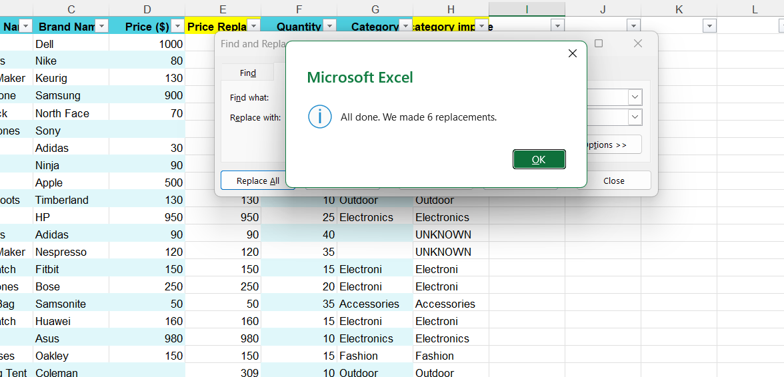
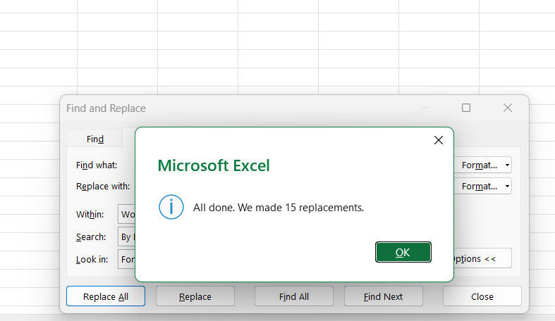
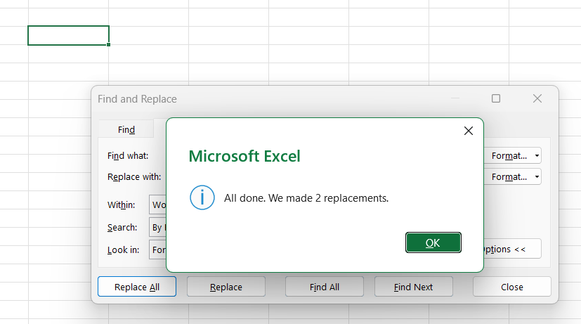
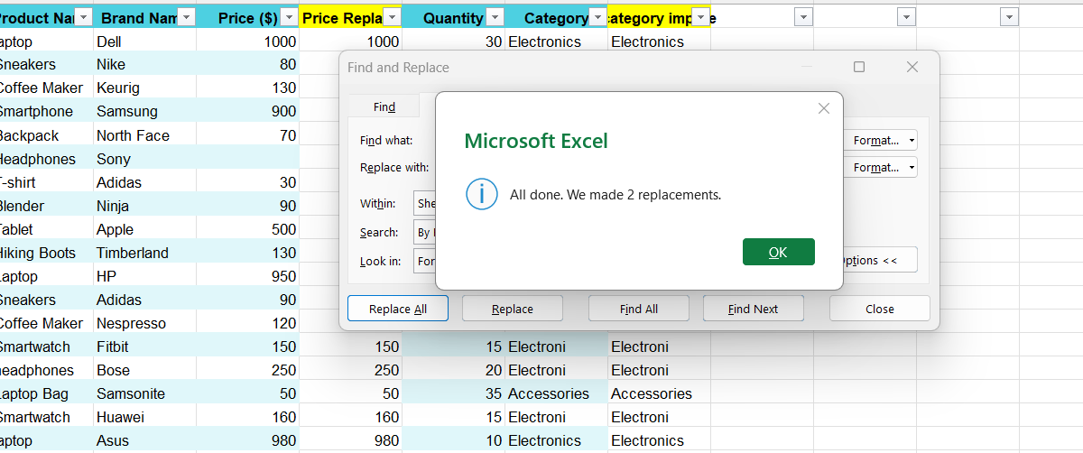

- Removing Duplicates:
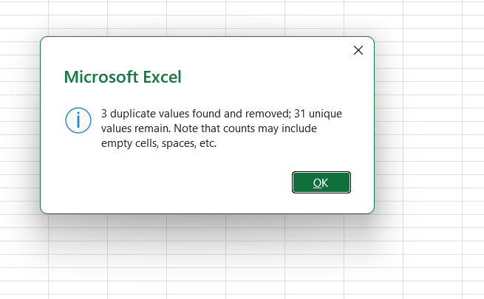

- Splitting and Merging Data:
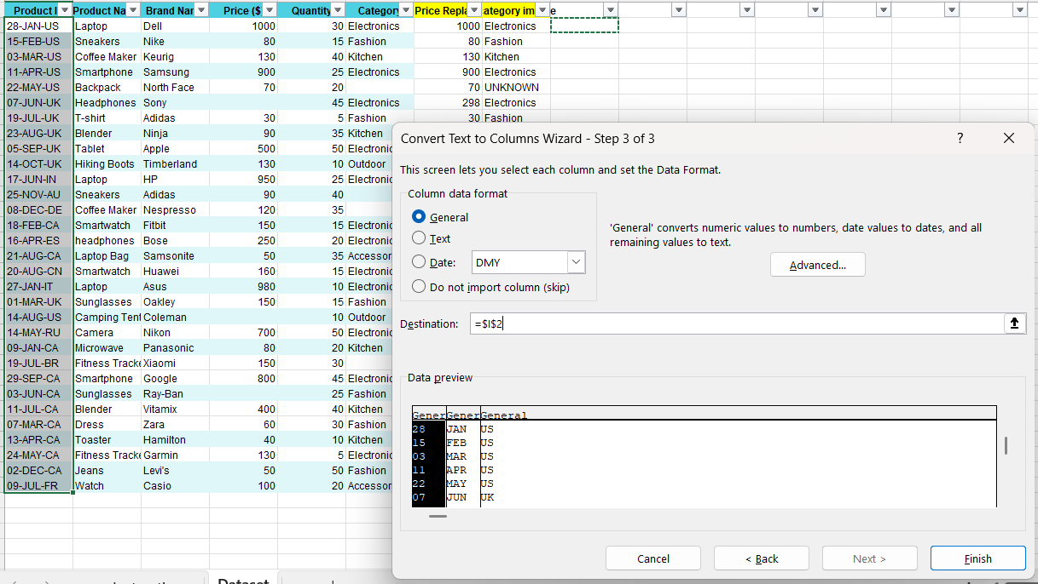

=I2& "-" & J2

Product Brand =C2&" "&B2

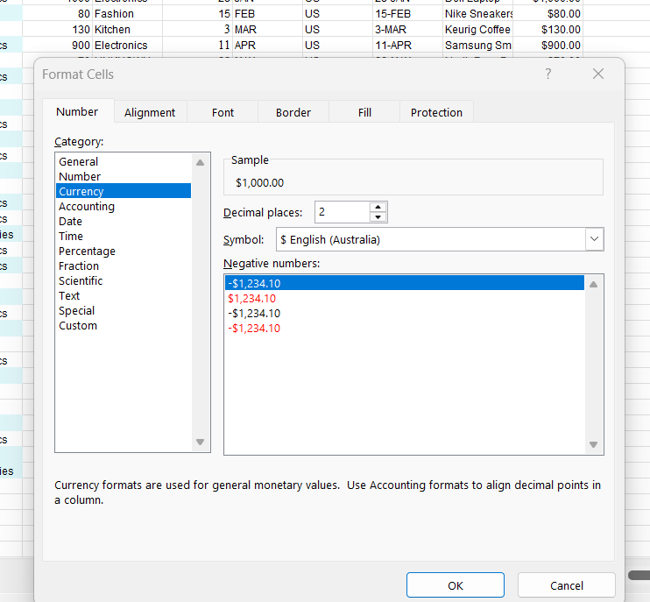
- Number Formatting:
a)

b)
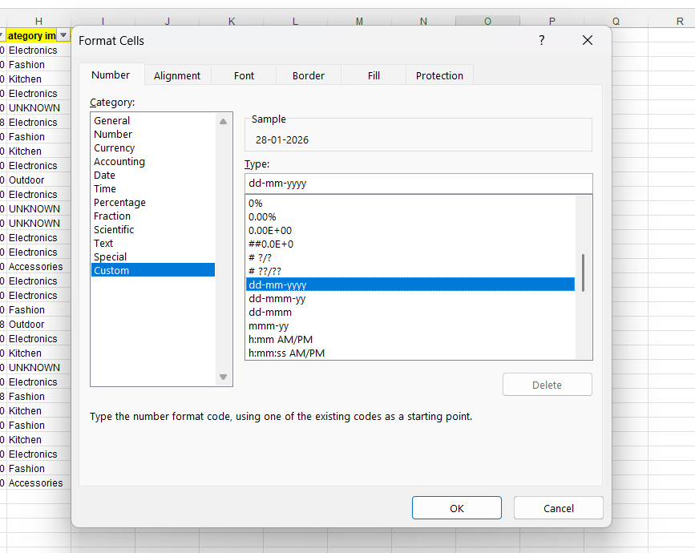

- Conditional Formatting:
- Home – Conditional Formatting – Data Bar
- Conditional Formatting-Highlight cells rules

